2025 DIGITAL CHILD SUPPORT ATTORNEY SOURCEBOOK
FREQUENTLY ASKED QUESTIONS
- Where can I purchase the digital sourcebook?
The Digital Sourcebook is available for purchase on CSDA website: Store - CSDA (csdaca.org).
- What format is the digital book available in?
Our digital book is distributed through Flipping Book. You will receive a document from CSDA with the link to access the book.
- How do I download the digital book?
After purchasing the book, you will receive an email with a download link. Click the link and follow the instructions to download the book to your preferred device.
- Does the digital version have protected access?
Yes, the digital edition is secured with a password.
- How do I receive the password?
When you click on the download link, you will be taken to the Info Hub website.
- Within the Info Hub, a left-hand navigation called Digital Downloads will be displayed.
- By clicking Digital Downloads, you will see a list of the downloadable products you have purchased and can click the in the Actions column to download the file.
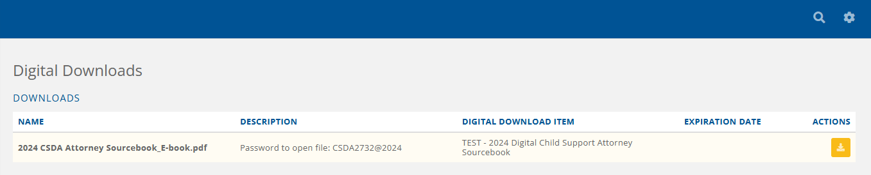
- The password is available in the product’s description as shown in the image below.

Please ensure that you keep this password both confidential and easily accessible, as you will need to enter it each time you open the book.
- Can I read the digital book on my Kindle/iPad/other devices?
No, the digital book is a password protected PDF file that is accessible through computers and tablets only.
- Do I need special software to read the digital book?
You will need a standard PDF reader like Adobe Acrobat.
- Can I print the digital book?
No, the Digital Sourcebook is protected and does not allow printing.
- Is there a limit to how many times I can download the book?
No, there is no limit to how many times you can download the book. If you encounter any issues or need additional downloads, please contact our customer support for assistance.
The book is also available for download in Info Hub.
- Within the Info Hub, a left-hand navigation called Digital Downloads will be displayed.
- By clicking Digital Downloads, you will see a list of the downloadable products you have purchased and can click the in the Actions column to download the file.
- What should I do if I lose the download link or have trouble downloading the book?
If you lose your download link or experience any trouble downloading the book, please contact CSDA at administrative@csdaca.org.
- Are there any restrictions on sharing the digital book?
The digital book is licensed for personal use only. Sharing, reselling, or distributing the book without permission is prohibited. Please respect our terms of use and support the authors by not sharing unauthorized copies.
- Can I get a refund for the digital book?
Due to the nature of digital products, we do not offer refunds. However, if you encounter any issues with your purchase, please contact CSDA, and we will do our best to resolve the situation.
- Will I receive updates if the digital book is revised?
Sourcebook is published each year. The current edition will not undergo any revisions or updates. We will release the 2025 version once it is completed, and a new purchase will be necessary.
- How do I contact customer support?
You can reach our customer support team by emailing administrative@csdaca.org or calling (916) 446-6700. Our team is available 9am – 5pm from Monday to Friday to assist you with any questions or concerns you may have.

